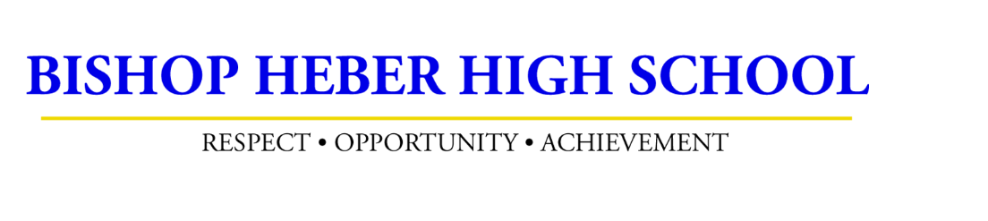
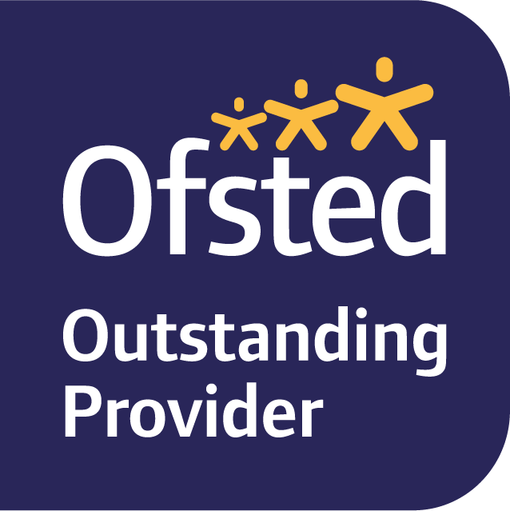
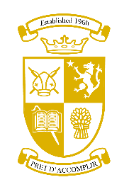

Vision: Our vision is a school in which respect, opportunity and achievement can flourish
The curriculum at Bishop Heber offers students a personalised programme of study, which is both challenging and versatile in supporting our community to achieve ambitious goals. It is an inclusive offer which is equitable for all and which will equip them for the world in which we live.
We want our students to be exceptional individuals who approach their future with self-assurance and respect for both themselves and others. They will be resilient, independent citizens who tackle challenges with perseverance and imagination.
The Curriculum
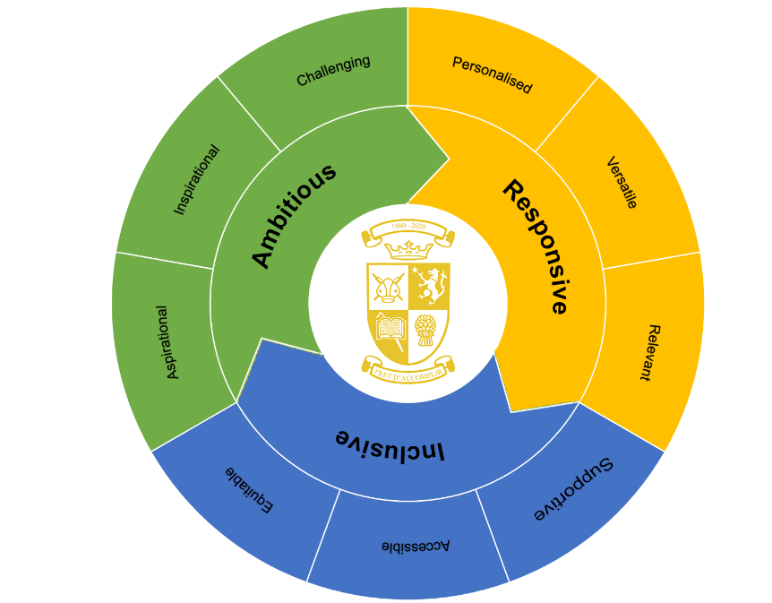

CURRICULUM OVERVIEW

Intent
Rationale
The school’s curriculum provides ambitious programmes of study for all students based on individual suitability and appropriateness regardless of sex, gender reassignment, pregnancy and maternity, sexual orientation, race, disability, religion or belief as outlined in the school’s Single Equality Scheme. The school’s curriculum will provide a full broad and balanced program which promote the spiritual, moral, social and cultural (SMSC) development of students’ reading, writing, communication and maths (RWCM) skills. It is not narrowed and follow the statutory requirements of the National Curriculum and reflect the school aims and ethos.
Aims
We firmly believe that all students, irrespective of their starting point, are entitled to a broad and ambitious curriculum. To that end, we are delighted to offer a knowledge-rich curriculum, which enables any student at Bishop Heber to fulfil their potential and develop the all-important skills and qualities, which will serve them well in later life.
The curriculum reflects our vision as a school in which respect, opportunity and achievement can flourish. Our curriculum delivers vital subject knowledge and skills, which are complemented by a diverse range of enrichment activities that broaden and extend the student experience.
The curriculum is designed to give all students the opportunity to develop as enquiring individuals who feel valued and respected, so that they, in turn, learn to value those around them. Equality of opportunity is a key principle in the design of our curriculum model and we fully support and promote the entitlement that students have to study the English Baccalaureate.
We operate a curriculum model with three years assigned for the delivery of our Year 7, 8 and 9 national curriculum programmes of study. These programmes of study have been carefully crafted to ensure that they go beyond the requirements set out by the National Curriculum.
At the end of Year 9, students opt for subjects that they will study in Years 10 and 11 and they complete those subjects by the end of Year 11. Our highly flexible two-year curriculum delivered in Years 10 and 11 allows us to create personalised guided pathways for our students.
Enrichment activities underpin our school culture and further prepare students for life in modern Britain. We use the enrichment activities to further enhance wider personal development and promote responsibility, respect, tolerance and positive attitudes to learning taught within the PSHCE programme.

The school’s curriculum aims to:
- Encourage high aspirations and maximise progress and potential
- Support students who have lost learning due to the impact of COVID
- Prepare students so they become responsive and independent individuals who are ready to meet future challenges and the world of work
- Provide students with an entitlement to rewarding learning experiences and essential IT, literacy and numeracy skills
- Create opportunities for students to co-operate, embrace diversity and show tolerance respect and fairness
- Promote healthy lifestyles
Full details of curriculum models and subjects available at each Key Stage can be found in Appendix A.

Implementation

Features of the Key Stage 3 Curriculum (Years 7-9)
- All students follow a programme of personal, social, health citizenship and enterprise education (PSHCE) that includes elements of British values, sex and relationships, drugs, political awareness, careers and personal finance education. This is taught by the students’ tutor, with specialist inputs where appropriate
- All students follow the statutory programmes of religious (locally agreed syllabus) and physical education
- In addition to a core of mathematics, science and English, all students follow courses in art, design & technology, the performing arts, computing and humanities
- All students study a modern language (Spanish or German) in Years 7 to 9
- Those in most need will be given access to the national tutoring programme will be provided to support catching up.
- In Year 7 a fortnightly learning to learn lesson is used to develop academic vocabulary and reading skills
- In Years 7 & 8 primarily numeracy skills which are needed to access the wider curriculum are developed through a fortnightly STEM lesson
- Year 7 students who need additional support in their numeracy and literacy skills to close the gap with their peers receive up to four additional periods per fortnight in additional English and/or maths instead of learning to learn and/or STEM.
- Year 8 students in the lowest set will receive one additional maths lesson instead of STEM.
- In Year 8 to 11 an aim higher further language is provided by offering French (period 6 after school)
- In Year 9 all students study for their Level 2 ICDL exam as part of computer science.
- The taught curriculum in all years is enhanced by a full extra-curricular programme and enrichment activities

Features of the Key Stage 4 Curriculum (Years 10-11)
- All students follow a programme of personal, social, health citizenship and enterprise education (PSHCE). This includes elements of British values, sex and relationships, drugs, political, religious, careers and personal finance education. This is taught by the student’s tutor, with specialist inputs where appropriate
- In Years 10 and 11 all students follow a core curriculum for all which includes; English language, English literature, combined science, mathematics, physical education, PSHCE and religious education
- There are two pathways for students to follow. The majority of students will follow pathway A.
  - Pathway A: Includes a modern language and three options. This will normally lead to the EBacc being completed
  - Pathway B: Includes a selection of vocational subjects including non-GCSE Level 2 courses
- With both pathways students have the opportunity to opt for courses in art, business, computing, design & technology, humanities, media, modern languages and performing arts
- In Key Stage 4 students can opt to study science as separate disciplines
- Those in most need will be given access to the national tutoring programme to provide additional support to bridge any gaps
- The taught curriculum in all years is enhanced by a full extra-curricular programme and enrichment activities

Features of the Key Stage 5 (Sixth Form) Curriculum
- In Lower Sixth students normally choose three subjects at Level 3 to study over two years
- Extension studies are offered in maths where a student can also study further maths
- In Lower Sixth students can opt to undertake the Extended Project Qualification (EPQ)
- In the Upper Sixth some students have the opportunity to study two subjects and complete work experience, approved by the school, as their third option
- Each subject is usually studied for nine periods per fortnight over the 50 lesson two week cycle
- All students follow a programme of personal, social, health and citizenship education that includes elements of sex and relationship, drugs, political, careers and personal finance education. This is taught alongside the curriculum in assemblies, tutor time and off timetable events
- There is a student enrichment lesson which complements the PSHCE programme and is taught by a specialist team
- Students who have not achieved a grade 4 or better in GCSE in English or maths are required to continue to study these subjects (GCSE/iGCSE/Functional Skills). Students will retake these exams in the Lower Sixth
- The taught curriculum in all years is enhanced by a full extra-curricular programme and enrichment activities

Monitoring and Review
The curriculum provision will be monitored by the Deputy Headteacher, who will report to the Governors and Headteacher on its implementation on a regular basis.

Appendix A - Curriculum Structure 2021-2022

Key Stage 3 (Years 7 to 9)

Number of periods per two-week cycle of 50 periods

Year 7 | Periods | Year 8 | Periods | Year 9 | Periods
English | 6 (7) | English | 6 | English | 6
Maths | 6 (7) | Maths | 6 (7) | Maths | 7
Science | 6 | Science | 6 | Science | 6
Physical Education | 4 | Physical Education | 4 | Physical Education | 4
PSHCE | 2 | PSHCE | 2 | PSHCE | 2
Religious Education | 2 | Religious Education | 2 | Religious Education | 2
Art | 2 | Art | 2 | Art | 2
Computing | 2 | Computing | 2 | Design & Technology | 4
Design & Technology | 4 | Design & Technology | 4 | Drama | 2
Drama | 1 | Drama | 2 | ICDL (IT) | 3
German/Spanish | 5 | German/Spanish | 5 | German/Spanish | 5
Geography | 3 | Geography | 3 | Geography | 3
History | 3 | History | 3 | History | 3
L2L | 1 (0)* | Music | 2 | Music | 1
Music | 2 | STEM | 1 (0)*
STEM | 1 (0)*

*In Year 7, students who have not made the DfE threshold of 100 KS2 points will be provided with two additional periods of extra English and/or maths support per fortnight. These periods comprising literacy and numeracy development work enabling them to close the gap with their peers. They take place instead of learning to learn or STEM.

In Years 8 some students in the lower maths set will continue this support instead of STEM.

Other opportunities in Key Stage 3 include:

Art | Music Bands & Performance | Representative Sports | Performing Arts Productions | ATC & CCF
Government | Duke of Edinburgh’s Award (Bronze) | Junior Maths Challenge | Trips & Visits (Inc. Activities Week) | Cultural & Language
Leadership | Mindfulness & Wellbeing | Work Related Learning

Key Stage 4 (Years 10)

Number of periods per two week cycle of 50 periods

Year 10 |  |  | Periods
English |  |  | 7
Maths |  |  | 8
Science |  |  | 9
Physical Education |  |  | 3
PSHCE |  |  | 2
Religious Education |  |  | 1
Year 10 – Languages Pathway | Periods | Year 10 – Non Languages Pathways | Periods
German/Spanish | 5 | Vocational Option | 5
Option 1* | 5 | Geography/History | 5
Option 2* | 5 | Option 1 | 5
Option 3* | 5 | Option 2 | 5

*Students on the Language Pathway would normally be expected/advised to do Geography/History

Key Stage 4 (Years 11)

Number of periods per two week cycle of 50 periods

Year 10 |  |  | Periods
English |  |  | 7
Maths |  |  | 8
Science |  |  | 9
Physical Education |  |  | 3
PSHCE |  |  | 2
Religious Education |  |  | 1
Year 11 – Languages Pathway | Periods | Year 11 – Non Languages Pathways | Periods
French/German/Spanish | 5 | Vocational Option | 5
Option 1* | 5 | Geography/History | 5
Option 2* | 5 | Option 1 | 5
Option 3* | 5 | Option 2 | 5

*Students on the Language Pathway would normally be expected/advised to do Geography/History

The Key Stage 4 options are decided after students have initially indicated their preferences. Therefore, the offer varies year on year. However, the courses on offer will be selected from those below:

GCSE Art | BTec Engineering | GCSE Media
ASDAN | OCR Enterprise & Marketing | GCSE Music
GCSE Business | GCSE Food Preparation & Nutrition | GCSE Photography
GCSE Computer Science | GCSE Geography | GCSE Physical Education
OCR Creative iMedia | GCSE German | GCSE Religious Studies
GCSE Design Technology | GCSE History | GCSE Separate Science
BTec Dance | EDUQAS Hospitality and Catering | GCSE Spanish
GCSE Drama |  | BTec Sport

Other opportunities in Key Stage 4 include:

Student Leadership | Work Experience | ATC & CCF | Duke of Edinburgh’s Award (Bronze) | Performing Arts Productions
Art | Music Bands & Performance | Intermediate Maths Challenge | Representative Sports | Mindfulness & Wellbeing
NCS | Trips & Visits (inc Activities Week)

Key Stage 5 (Sixth Form)

The sixth form options are decided after students have initially indicated their preferences. Therefore, the offer varies year on year. However, the courses on offer will be selected from those below:

Applied Business (BTEC) | French | Physics*
Art | Further Mathematics | Politics
Biology* | Geography | Product Design
Chemistry* | German | Psychology*
Computer Studies | Health & Social Care (BTEC) | Religious Studies
Economics | History | Spanish
English Language | Mathematics | Sport (BTEC)
English Literature | Media Studies | Sociology*
Extended Project Qualification* | Music | Theatre Studies
Food & Nutrition | Music Technology | Tourism*

Students who have not achieved a grade 4 in English language or mathematics will have to continue to study these subjects, undertaking a GCSE, iGCSE or Level 2 numeracy course.

Student may extend their studies with a fourth A-level in further mathematics or the Extended Project Qualification (Lower Sixth only)

Other opportunities in the Sixth Form include:

Arkwright Scholarship | In class support | Nuffield Bursary in Science | Student Leadership | Work Experience
Duke of Edinburgh’s Award (Gold) | NCS | Senior Maths Challenge | Representative Sports | Study Support & Revision
ATC & CCF | Trips & Visits

*subjects that can be examined at A/S in the Upper Sixth

